Mary Rayner, Director of Operations, Stormwater Shepherds, 25 Nov 2021

Toxic Microplastic Pollution from our Vehicles Tyres

We all will agree stormwater is the principal polluter in Australia’s waterways - the plastic and urban pollution freeway direct to our riparian waterways, harbours, bays and oceans.

During my journey talking to councils, councillors, politicians and community members, there was a poignant moment when I understood the missing jigsaw piece in stormwater management. It seems the knowledge about the dire ramifications of untreated stormwater and the effects on all aquatic lifeforms, including humans, is missing. I believe that without being armed with the facts, it's harder to harness the appropriate action required in treating stormwater correctly.

I have chosen road runoff, specifically tyre wear pollution (TWP), 1) due to the severity of its effects on aquatic lifeforms, and 2) we are only now wakening up to the fact that TWP is a significant pollutant in stormwater.

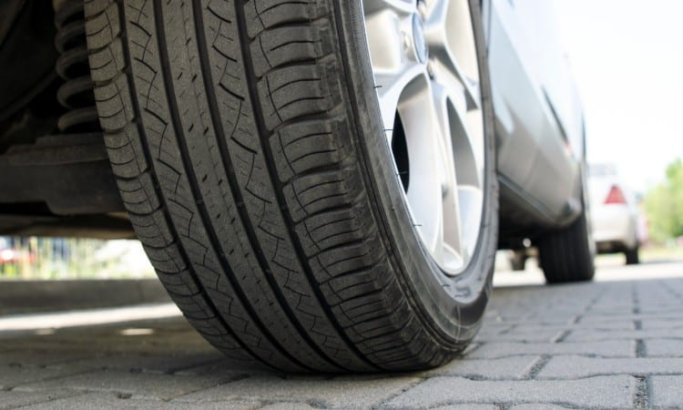
Tyre wear pollution from toxic micro and nano plastics are a much bigger problem than we realise. Emissions Analytics, a UK-based independent global testing and data specialist, reports that vehicle tyre wear is entirely unregulated across the world and pollution from these tyres is possibly 1,000 times worse than the pollution from a car's exhaust. The situation intensifies with a vehicle's weight – trucks, SUV's and electric vehicles from their battery.

What is tyre wear pollution?

Designed to degrade, modern tyres lose between one kilogram to four kilograms in weight during their useful life. Toxic micro and nano tyre wear plastics are the result of the degradation.

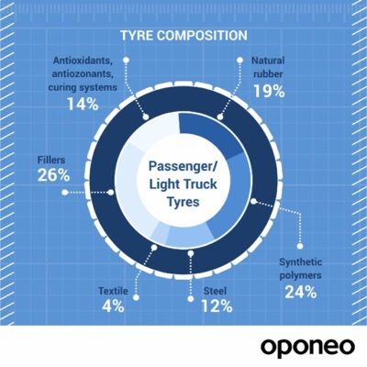
Composed of 19% natural rubber and 24% plastic polymers, the remainder are metals, (steel wires under the tread), plastic fabrics like polyester and nylon, carbon black and silica fillers, and chemicals used to preserve, strengthen and cure the rubber, e.g., Sulphur and Zinc Oxide).

TWPs are some of the most significant sources of microplastic in our inland waterways and oceans. While more studies are needed to estimate how big a problem TWPs are, a 2021 report by the European Commission estimates that 1.3 million tonnes of TWPs are generated in Europe each year. Further, the US produces 1.8 million tonnes of TWPs, and tyre wear contributes 50% of Denmark's and Norway's microplastics. Stormwater is responsible for conveying between 90-95% of the microscopic black fragments to our riparian environments and oceans, and the remainder disperses as road dust through the air.

There are around 81.2 million vehicle tyres in Australia, and each year we drive 238,499 million kilometres, generating approximately 28,000+ tonnes of TWP.

Uneven road surfaces, the vehicle's weight, tyre pressure, wheel alignment, vehicle speed, ambient temperature and how we drive all factor into how many bits of tyres break off from the friction between tyres and the road, thus becoming road sediment. These fragments are often elongated, like a cigar shape, sticky, thus attracting road wear elements to attach. When these plastic particles reach inland waterways and oceans, they sink to the bottom of the water due to their density – water is 1 gram per square centimetre, and tyre wear is approx. 1.7, which possibly explains why they have gone pretty much undetected until recent years.

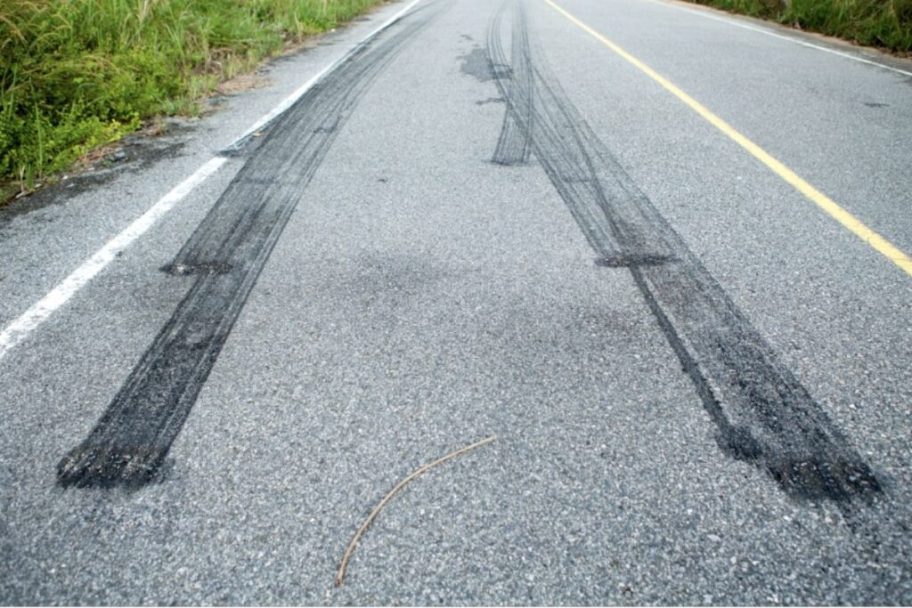
Erratic and sudden braking sheds TWPs, causing skid marks

Other contaminants arise from road wear pollutants - fragments from asphalt and concrete road surfaces, road markings and containments from car emissions – hydrocarbons and heavy metals.

How does tyre wear pollution affect the environment?

Road sediment pollutants from vehicles - tyres, heavy metals and oils, flush into stormwater networks during rain events. The heavier the event, the more road sediment is washed off the roads and into stormwater networks, and prolonged rain events transport the road pollution further before settling in creeks, rivers, harbours and oceans.
The problem with tyre and road wear runoff is that it is hard to measure the environmental impacts from the complex, insidious effects caused by the chemicals - toxins from heavy metals and PAHs and Endocrine Disturbing Chemicals (EDCs). In fact, all microplastics polluting the planet predominantly display EDCs. These chemicals affect humans’ endocrine system by:
- Male and female reproductive issues - - Reduction in sperm quality and fertility and abnormalities in male sex organs
- Cancers in younger people - thyroid, breast and prostate
- Adrenal and thyroid disorders
- Neurodevelopmental issues in children, such as ADHD, autism & learning disabilities
- Disrupted immune function
- Early puberty
- Altered nervous system function, more people are suffering anxiety
- Diabetes, obesity, cardiovascular problems and more
Whereas it’s much harder to gauge the effects from EDCs on aquatic biota. We know toxins and EDCs are suppressing species populations, they are less healthy, and many populations are diminishing in size. But research is limited on the health of a waterbody’s sediment. A Swedish literature review, Microplastics from Tyre and Road Wear, cited reduced growth or growth inhibition, reduced number of offspring, delayed development, deformity and death from toxicity studies on tyre tread and tyre and road wear particles ingested by marine and aquatic sediment-dwelling organisms, mainly small crustaceans and fish, algae, and tadpoles. The laboratory studies centred around the toxicity released from chemicals in different leaching conditions.

When ingested tyre rubber sticks in an organism’s gut the rubbery microplastics leave no room for food, resulting in a slow death from starvation. Research has identified during starvation; the organism becomes lethargic and ceases to breed. Finer particles can entangle tiny organisms to be immobile.

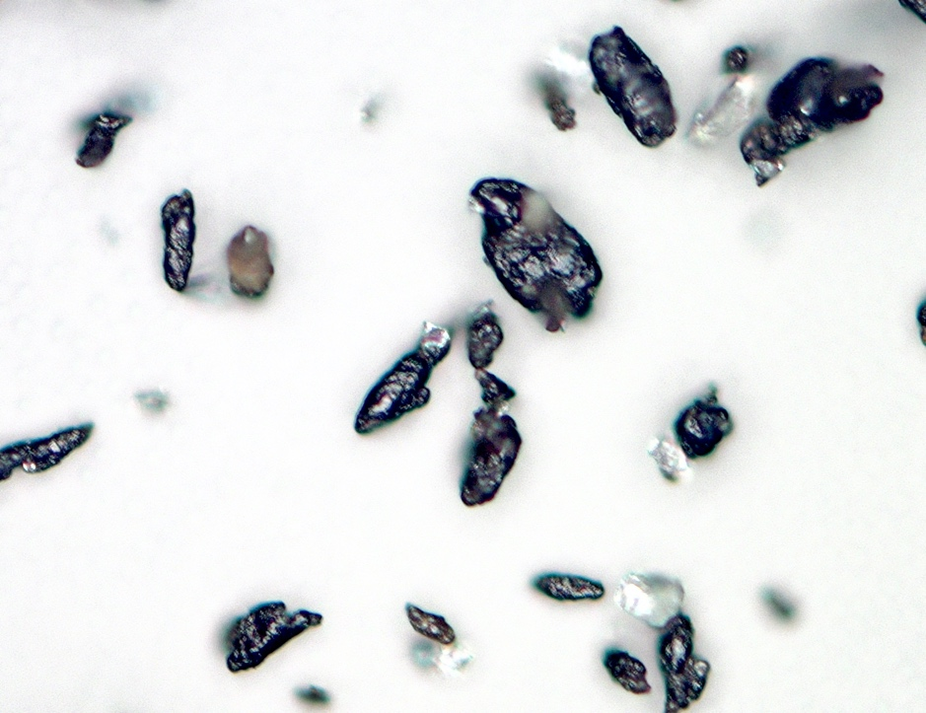
Close up of sticky tyre wear particles, some with other pollutants attached. Photo courtesy of Karl-Johan Lorents, Sweden

We need to be careful not to overlook the potential total collapse of ecological communities from the loss of primary producers of food chains from a lack of research and unmanaged stormwater.

Tyre wear pollution causes environmental harm in many ways:
- A recent study in the US identified a direct link between tyre wear and the poisoning of marine life. A preservative used in a vehicle’s tyre, 6PPD, is causing mass die-offs in Coho salmon on the country’s west coast.
- Water bugs and terrestrial insects also ingest the rubber tyre fragments and it is noticeable that there are less insects around, particularly in stormwater channels. Researchers at the National Oceanic and Atmosphere Administration Northwest Fisheries Science Center, Seattle, USA observed a 26% reduction in insect populations, with reduced species diversity in urban stormwater.

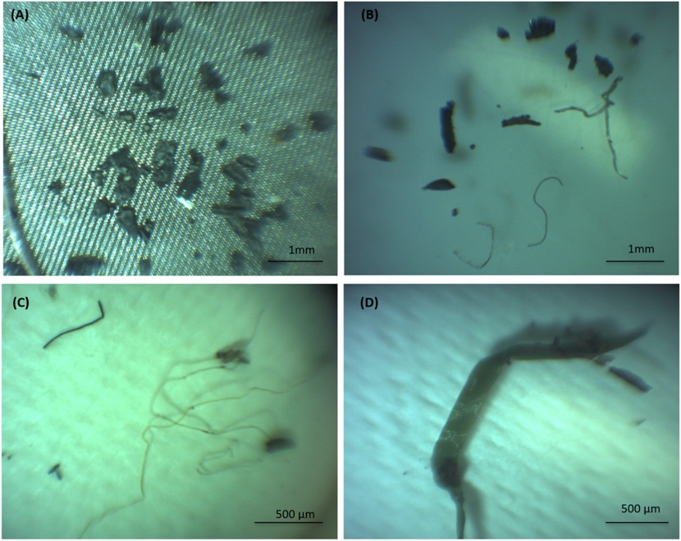
Microplastics extracted from water and sediment, from a floating treatment wetlands - poly(styrene-co-ethylacrylate) black fragments (A), butyl rubberblack fragments (TWP) (B), polyethylene fibres (C) and acrylic fibres (D).
- TWPs move up the food chain as sediment-dwelling organisms, ocean bottom eating mammals (such as dugongs), fish, shellfish, and birds eat them, poisoning hundreds of different species, and with a bioaccumulation effect on humans.
- Other toxic organic compounds in stormwater runoff ‘stick’ to TWPs, creating even more toxic particles that get carried into nearby waterways and ingested by biota.
- Tyre wear particles in sewage and stormwater are captured during treatment and end up in 'sewage sludges' that are spread to agricultural lands. Scientists are now finding tyre particles in the soil where food crops are grown, and in the fruit and vegetables we eat. A recent NSW study found that microplastics can block soil pores, preventing or limiting plant growth because air and water can’t move properly through the soil. Further research estimates that microplastic concentration in soils and freshwater ecosystems is between 4 and 23 times higher than in the oceans.. Once in the soil, microplastics are impossible to remove.
- Wind also carries tyre particles for up to many hours. As airborne pollutants, they can be inhaled by humans and animals, and the amount of harm they do is not yet fully understood. Currently, research is underway to understand if the particles can harm humans and other animals' when they pass into the bloodstream and internal organs.

It is not just pollution from vehicle tyres that are wreaking havoc in our waterways; studies in Norway have identified artificial turf pitches, playgrounds, and paths release micro and nano plastics, or granules, made from recycled vehicle tyres. The granules help the artificial turf stand up and provide a softer foundation that reduces injuries. From Norwegian research, artificial turf fields alone release 65 tonnes of rubber granules annually on clothing and shoes, or approximately 10,000 tyres. Washing machines flush away most of the pollution direct to the ocean. However, Scientists estimate stormwater conveys around 3,200 tonnes annually to inland waterways. (More about this in a future article).

There is limited research on the effects of inhaling and absorbing the rubber dust on players and children. However, airborne fragments smaller than 4 µm can penetrate the alveoli of the lungs.

Diverting road runoff

A plethora of opportunities using correctly treated road runoff and stormwater is the future. The NSW Draft Greater Sydney Water Strategy identifies - increasing stormwater retention by maximising previous land surface area, diverting roadway runoff into raingardens and using stormwater to support increased vegetation coverage (pg. 98).

However, harvested stormwater for use elsewhere must be correctly treated stormwater. We can't continue contaminating agricultural and natural soils by transferring more microplastics to poison sediment-dwelling organisms and vegetation.

So, what can we do?

The good news is that the future is not all doom and gloom. There are some simple ways to reduce the amount of TWPs we produce as well as methods to capture these particles before they escape into the environment:
  - In a tyre and road wear particles review, developed by Science of the Total Environment, recommendations include:
    - Installing sufficient stormwater treatment systems.
    - Retrofitting existing systems.
    - Improving runoff treatment systems at rural roads and highways and regular control and maintenance of drainage systems, including correct disposal of sediment (not on agricultural or natural soils). Treatment systems include constructed wetlands, vortex separators, oil water separators, stormwater filters, detention tanks and ponds and vegetative swales, stormwater ponds, sedimentation basins.
    - We can improve our driving – avoid erratic and sudden braking that causes more particles to break off from our tyres, reduce our speed and use our vehicles less.
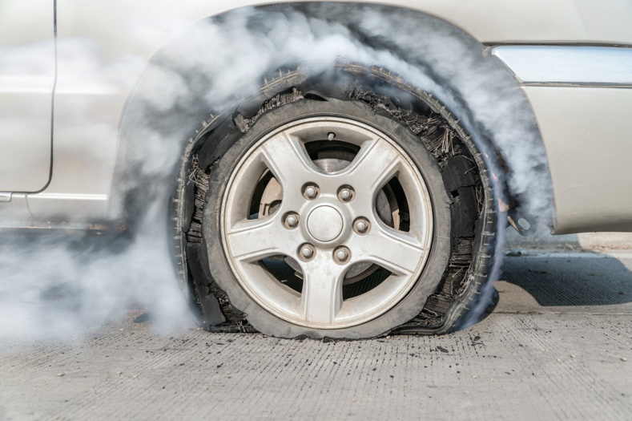
Maintaining our tyres – don’t wait until our tyres are thread-bare to change them

Maintaining roads – Maintain road surfaces regularly. Councils can increase street sweeping. However, depending on the technology used, street cleaning can also lead to increased tyre and road particles dispersing in the air from micro and nano plastics smaller than 10 µm.

  - Wash vehicles at a commercial car wash. Tyre and road wear can stick to a vehicle's body, so when we wash our vehicles, the particles wash off into the flow of water. Germany has banned washing vehicles at home, and Sweden's Environmental Code bans all planned land and water pollution. I.e., washing a car on the street is perceived as planned water pollution.
  - Instead of spreading sewage sludge on agricultural lands and natural soils, incinerate sludge that contains large amounts of tyre wear particles, microfibres and other micro and nano plastics.
  - The tyre-manufacturing industry can design tyres that are higher in durability and wear resistance and not hazardous to the environment.
  - Incorporate the biological health of urban areas in developments plans and policies to correctly manage stormwater networks.
  - It's long past the time we fund stormwater correctly. Governments and councils need to urgently explore and adopt user-pays models to pay for correctly treated stormwater runoff.
Traffic-related measures such as reduced speed limits, driving lighter vehicles, traveling less in a vehicle will reduce the amount of TWP. We will also enjoy reduced environmental impacts such as CO_{2,} and NO_{x} emissions and noise pollution.

While research is underway across the globe to find practical solutions to tyre wear and road runoff pollution, one crucial part the community and the stormwater industry can play is to discuss unmanaged stormwater with our local councillors and state and federal MPs about better care and regulation of stormwater networks.

Finally, it’s interesting to read that the United Nations has noted an increase in Climate Crisis lawsuits against governments and corporations, globally, under Fundamental human rights for clean water and safe food.

Climate science is supporting lawsuits that could help save the world!

Stormwater Shepherds is a global, environmental not-for-profit. Their charter is to restore inland waterway environments by stopping plastic and urban pollution at the source – the home, the business and the stormwater drain through positive action, education and advocacy.
Stormwater Shepherds acknowledges SPEL Environmental as their principal supporter i

